**USC Inmap**

Final Project Case Study

Group3: Dengjia Zhang, Jiacheng Weng, Junye Li, Lei Cao

DSCI 556

12/3/22

Table of Content

**Introduction** **3**

**Problem Statement** **3**

**Value Proposition** **3**

**Customer Discovery & Validation** **4**

Empathy Map 4

Provisional Persona 5

Discovery Interviews 7

Interviews Summary 7

Discovery Interviews Findings 8

**Competitive Research & Analysis** **9**

Direct Competitors 9

Indirect Competitors 13

Most Threatening Competitors 17

Current Marketplace 17

Opportunities and Recommendations 17

**Feature Definition & Prioritization** **18**

Navigation 18

Indoor Map 18

Virtual Tour 18

Discussion 18

**Designing Key Experiences** **19**

Scenarios 19

Storyboards 20

**Prototype Development** **23**

Prototype 23

User Research 25

Design Iterations 27

**Business Model Canvas & Lean Canvas** **32**

Business Model Canvas 32

Lean Canvas 33

**Conclusion** **34**

Reflection 34

Recommendations 34

Next Steps 34

# Introduction

On the first day of school, some USC students spent about 30 minutes on finding the classroom. Some students haven't found their classrooms after class has started. There are many reasons for this to happen. One reason could be there is no indoor navigation application for students to use. Another reason is that it is hard for students to find the floor plan in the building. In order to solve this problem, we decided to create a mobile application called USC Inmap in which we conduct some interviews and create a prototype for this.

# Problem Statement

USC campus is large and has so many buildings. Some USC students and professors have difficulty finding the exact location of the classroom, especially at the beginning of the semester.

# Value Proposition

USC Inmap is a digital platform that can navigate customers inside the USC building to find the exact room, show the indoor map online, and provide an online gathering place where students can ask questions.

# Customer Discovery & Validation

## Empathy Map

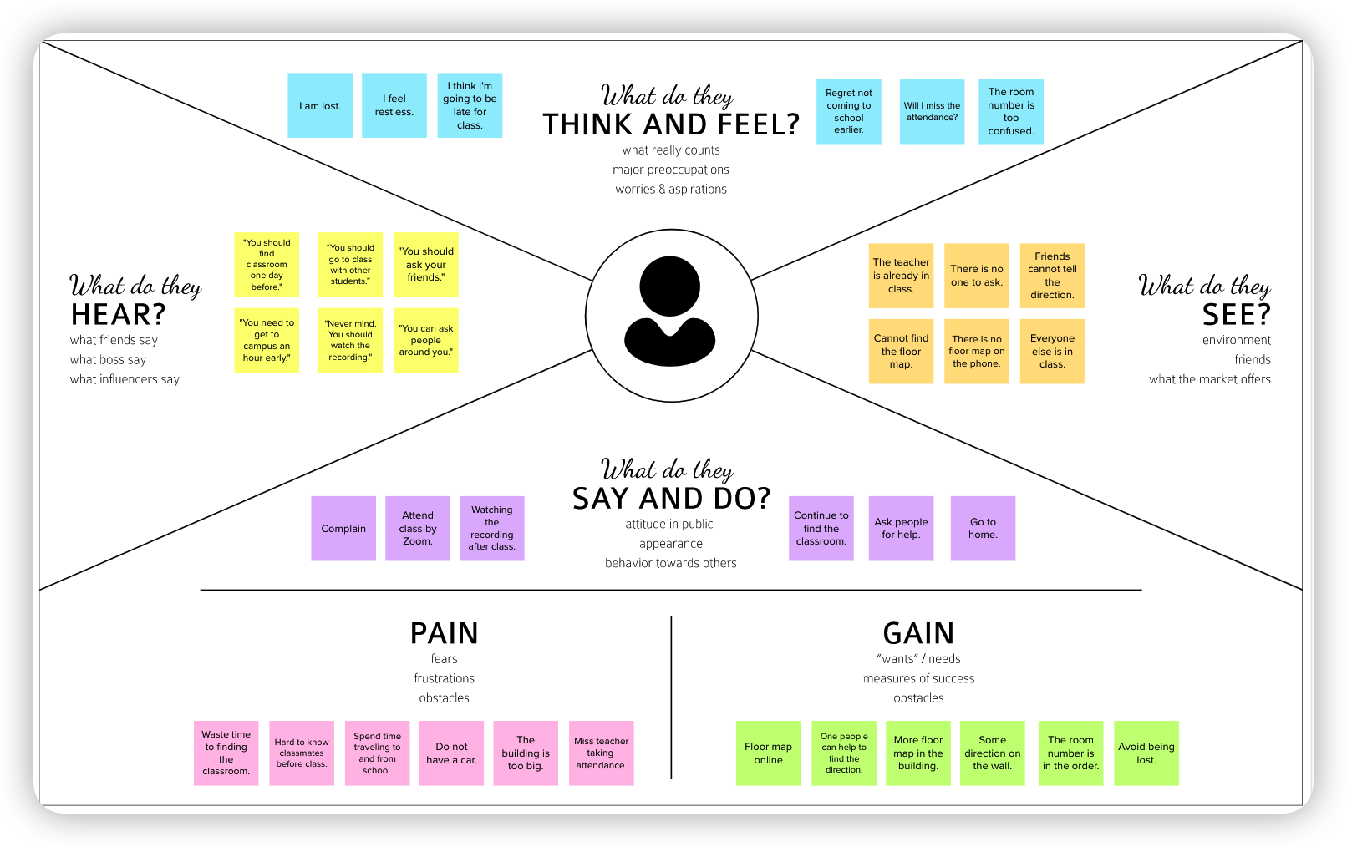

We used the empathy map to abstract students who were having trouble finding their classroom for the first time. This is a combination of four group members' empathy maps, with points that we all expected to come up with, such as "I got lost," "I went home to the Internet," "I asked for help," etc. We felt a great deal of empathy for the difficulties the students were having in finding their classrooms.

## Provisional Persona

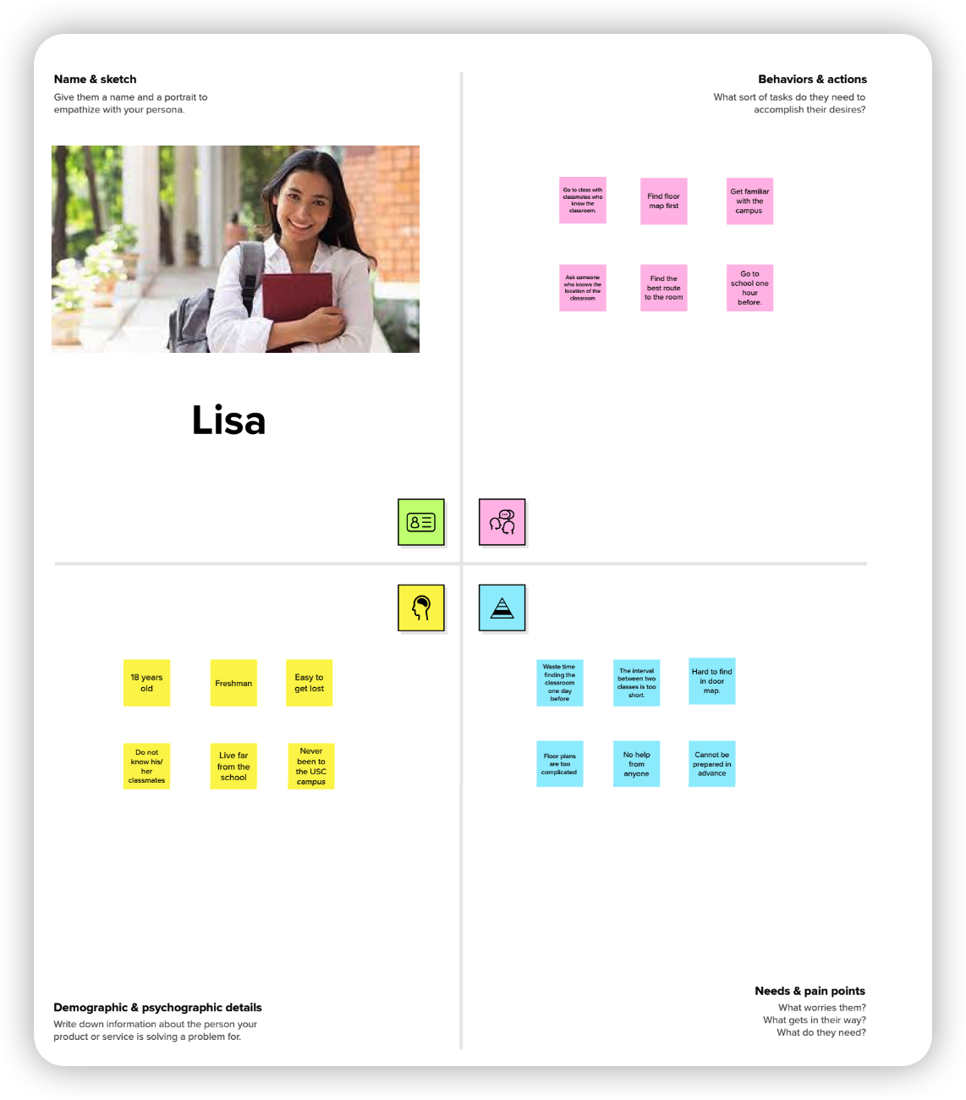

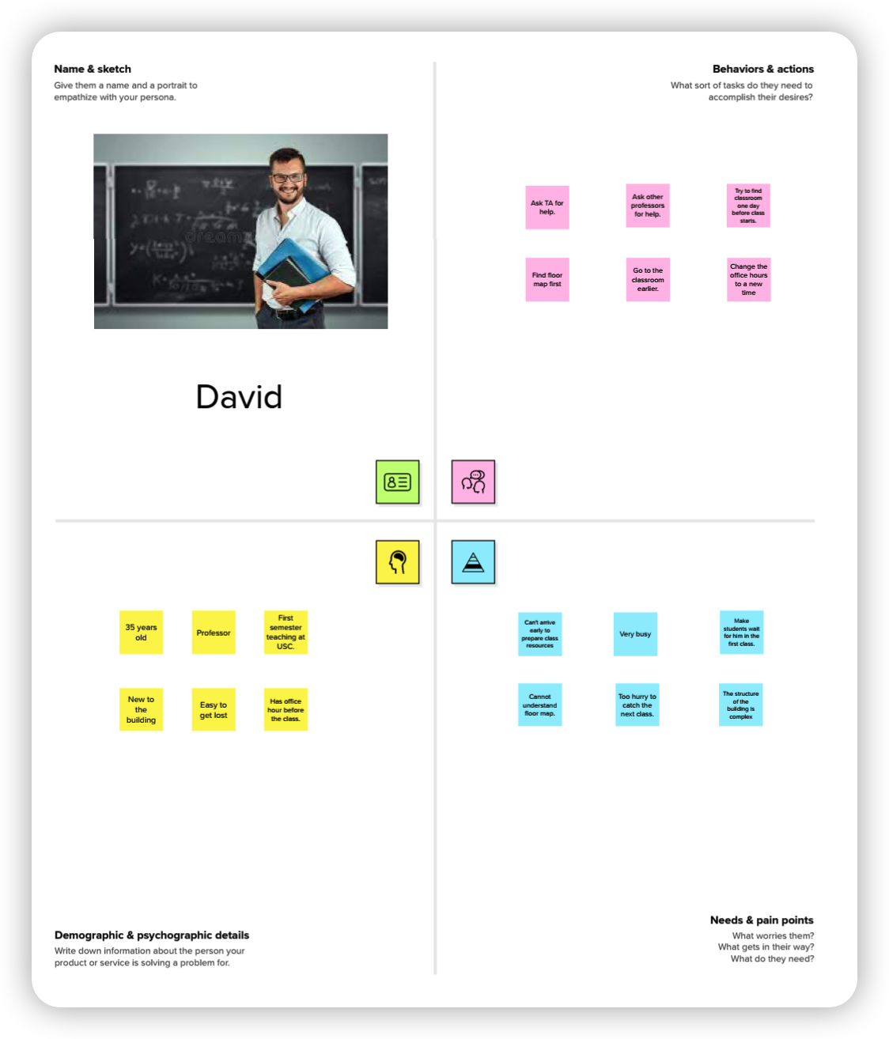

Based on the empathy map, we constructed two provisional personas: one for Lisa as a student and one for David as a professor. We depicted the potential behaviors, attitudes, and requirements of these two characters, who represented what we thought of as our key users. In these two exercises, we learned more about our possible target users.

## Discovery Interviews

### Interviews Summary

#### Lalong S.

* Male, 26
* USC Graduate Student
* Values time, efficiency and clear path
* Hope not to waste my time on getting lost
* “At the beginning of this semester, it’s a little bit difficult to find the classroom for each class. If it's a building I know well, I can find the classroom quickly, otherwise it may take 10 minutes. I asked some students in the building. But I was still a little late.”

#### Muzi L.

* Female, 24
* USC Graduate Student
* Values time
* She wants to schedule her time as wisely as possible. She wants neither to be late nor wait outside the classroom for a long time.
* “I am not familiar with the route to classrooms. I hope it will give me the route and direct me to the classroom”

#### Siying Y.

* Female, 23
* USC Graduate Student
* Value time
* She wants to have a product that guides her to buildings and classrooms.
* “So many abbreviations and there are too many classrooms on each floor. Maps with abbreviations and internal routes in the building can help me”

#### Xi C.

* Female, 24
* USC Graduate Student
* Value time and efficiency
* She wants to find classrooms faster at the beginning of the semester.
* “I think SGM room markers are too small, no signs or maps, SAL construction is strange. I hope your product can navigate inside the building, with elevator, stair and toilet locations indicated in the indoor map.”

### Discovery Interviews Findings

The customer discovery interviews validated our customer group. All interviewees have trouble finding their classrooms on the first day of the semester. They always used Google Map to help them find the building. However, Google Map or other navigation apps don’t support indoor navigation. They hope a product that could navigate indoors and USC can also take steps to help them find classrooms such as providing bigger and more visible indoor maps near the entrances.

# Competitive Research & Analysis

The direct competitors Navigine, USC Maps, Path Guide, ArcGIS Indoors, Matterport, and Waze are apps that focus on map and navigation, while the indirect competitors serve as

platforms for communication between users and publishing virtual tours.

## Direct Competitors

### 1. Navigation

* **Value Proposition**

Navigine is a global provider of integrated mobile indoor wayfinding and navigation technologies that enable advanced indoor and outdoor navigation and proximity solutions.

* **Pros**
  + Precise indoor and outdoor navigation
  + Map of indoor area and outdoor area
  + Location tracking
* **Cons**
  + Lack of functionality to communicate with peer users.
  + Only has a mobile version. No published website.
* **SWOT Analysis**
  + **Strengths**:

Navigation is a comprehensive mobile application of map navigation, including indoor and outdoor areas. Users could be guided by detailed and precise navigation.

* + **Weaknesses**:

Navigation misses some necessary functions, such as lack of functionality to communicate with peer users. A social media type feeling can reinforce the apps’ value.

* + **Opportunities**:

This app can be improved in terms of user specificity. For example, adding indoor maps of USC campus could make it more suitable to USC users.

* + **Threats**:

Indoor maps services are very mature and very easy to replace. And also, other products provide service not only through mobile apps but also websites.

### 2. USC Maps

* **Value Proposition**

USC Maps is a map website about USC campus and infrastructure, which contains the information of buildings or structures on campus.

* **Pros**
  + Dedicated and comprehensive map of the USC campus
  + Information of each building or structure on campus
* **Cons**
  + No indoor map inside the campus buildings
  + No navigation function
  + Information for each building isn’t detailed enough
  + Boring UI and UX design
* **SWOT Analysis**
  + **Strengths**:

A dedicated and comprehensive map of the USC campus about campus buildings and infrastructure, including space for campus living and study purposes. This app is very useful for the USC community.

* + **Weaknesses**:

USC Maps misses some necessary functions. It has no indoor map and navigation inside the campus buildings, which could be not useful if the user want to find a specific room rather than a building.

* + **Opportunities**:

From USC's official website, USC Maps has a monopoly in the market, as it’s the most common way for people of USC community to explore USC campus.

* + **Threats**:

USC Maps has boring UI and UX design, which makes it hard to use. And also, Indoor maps services are very mature and easy to replace.

### 3. ArcGIS Indoors

* **Value Proposition**

ArcGIS Indoors Maps is a platform that puts the power of indoor maps into the hands of everyone in your organization by delivering indoor navigation software and location-based experiences to your building occupants.

* **Pros**
  + Indoor geographic information system (GIS)
  + Space management software
  + Mobile version
* **Cons**
  + Hard to use for those who don't have professional experience in GIS
  + High service fees
* **SWOT Analysis**
  + **Strengths**:

Professionalism is the biggest advantage of ArcGIS Indoors. Users can use GIS to create extremely detailed maps and navigation.

* + **Weaknesses**:

Professional GIS knowledge is needed, so It’s hard to use for those who don't have professional experience in GIS. Hence, this app is not open to everyone and we can expect that the community won’t be huge.

* + **Opportunities**:

Provide guidance. Make the product more easy-to-use with some guidance or expert services. The guidance could contain some key GIS knowledge and step-by-step demo.

* + **Threats**:

Price and accessibility: the high service fees will hinder this product becoming widespread and limited accessibility will shrink its market opportunities.

### 4. Waze

* **Value Proposition**

Waze provides satellite navigation software on smartphones and other computers that support the Global Positioning System. It is also a community-driven app, which provides social media type feeling for users.

* **Pros**
  + Turn-by-turn navigation
  + Community-driven app
  + Free to download and use
* **Cons**
  + No indoor map or indoor navigation provided.
  + Slow loading and rendering
* **SWOT Analysis**
  + **Strengths**:

Except for maps and navigation, Waze is also a community-driven app, which provides social media type feeling for users. It combines maps and social media into one app to increase the attractivity for users.

* + **Weaknesses**:

Waze may have precision issues. And this app only focuses on outdoor navigation, so there are no indoor maps and navigation provided.

* + **Opportunities**:

Waze can expand services to attract more customers, such as developing the service for indoor navigation.

* + **Threats**:

There are many companies offering web-mapping service with more practical features, such as Google Maps and Apple Maps.

### 5. Matterport

* **Value Proposition**

Matterport provides 3D cameras and virtual tour software platforms to help you digitize your building, automatically create 3D tours, and schematic floor structure.

* **Pros**
  + An easy and convenient app to create indoor 3d tours
  + Professional digital devices and mobile apps provided
* **Cons**
  + Only focuses on displaying an inside view of the building rather than maps
  + No navigation function
* **SWOT Analysis**
  + **Strengths**:

Visualibility: the 3D virtual tours created by this product are pretty intuitive and attractive.

* + **Weaknesses**:

High price and missing feature: 3D cameras are too expensive for creating virtual tours. They only focus more on displaying an inside view of the building rather than on navigation.

* + **Opportunities**:

Add features: It's an easy and convenient app to create indoor 3d tours but more features could make this product more useful and attractive.

* + **Threats**:

Price: The price of 3D cameras hinder this product becoming widespread, so such a great product with less price will attract more users.

### 6. Path Guide

* **Value Proposition**

Path Guide is a completely map-free, infrastructure-free, plug-and-play indoor navigation service. It exploits the ubiquitous geomagnetism and natural walking patterns to guide users to destinations along a path collected by an earlier traveler.

* **Pros**
  + Map-free, infrastructure-free, plug-and-play indoor navigation
  + Free to download and use
* **Cons**
  + Tracks information cannot open for everyone.
  + No user community
* **SWOT Analysis**
  + **Strengths**:

Path Guide provides map-free, infrastructure-free indoor navigation service to guide users to destinations along a path collected by an earlier traveler.

* + **Weaknesses**:

Path Guide misses some useful information, such as lack of basic information about original maps.

* + **Opportunities**:

Path Guide can improve its user experience. For example, provide services by adding information about the user's own experience.

* + **Threats**:

Maps services are more important than map-free services. Many other companies integrated map services into their apps.

## Indirect Competitors

### 1. Google Maps

* **Value Proposition**

Google Maps provides route planning, real time traffic condition, satellite image and 360 interactive panoramic street view.

* **Pros**
  + Real Time traffic condition and route planning based on traffic condition.
  + 360 interactive panoramic street view
  + Precisised maps and navigation
  + Fully functioning website and mobile app
* **Cons**
  + It does provide 360 Street View. However, if the place is a remote area, such as the national park, then it will not provide
  + It does not remind people some routes are dangerous.
  + No indoor navigation.
* **SWOT Analysis**
  + **Strengths**:

Google Maps can show users 360 interactive street views. Also, it has real time traffic to help people choose the route.

* + **Weaknesses**:

Google Maps have some incomplete features and limitations. For example, Google Maps cannot show people street view everywhere, especially in National Park.

* + **Opportunities**:

This app can provide some dangerous signals to show users that some routes are dangerous.

* + **Threats**:

As a map and navigation app, the company has a lot of competitive pressure. Google Maps does not have a road view like Apple Map so people need to spend time analyzing which direction is right.

### 2. CloudPano

* **Value Proposition**

CloudPano 360° virtual tour software empowers you to create 360° virtual tours. It is a great platform for uploading, connecting, and publishing 360° virtual tours. It also provides a live video chat function for users.

* **Pros**
  + Software to create virtual tours.
  + Upload, connect, and publish a 360° immersive experience
  + Video chat live with clients.
  + Instant support and a large community await.
* **Cons**
  + Only supports cell phones, which are not as effective as specialized devices.
  + User experience and feedback are also relatively less.
  + No maps and navigation
* **SWOT Analysis**
  + **Strengths**:

CloudPano provides not only applications that create and display virtual tours, but also end-to-end solution services. The company CloudPano offers strong tech support to improve user experience.

* + **Weaknesses**:

Small Scale: The company of CloudPano is a small company, so it may not have enough staff to solve too many problems and users’ feedback, which may weaken its competitiveness and even lose customers and market.

* + **Opportunities**:

Virtual tour is an emerging Market. With the rise of VR and AR concepts, the demand for virtual tours are also increasing, so CloudPano has many potential or future users.

* + **Threats**:

There are many virtual tour apps on the market and they all provide similar functionality. However, due to the small scale, CloudPano can’t handle users’ problems or feedback in time.

### 3. RICOH360 Tours

* **Value Proposition**

RICOH360 Tours is a cloud-based platform to create interactive 360° Virtual Tours for homes and commercial properties. The RICOH THETA along with the RICOH360 Tours app makes it super easy to capture stunning, true-to-life 360° virtual tours.

* **Pros**
  + Easy to capture stunning, true-to-life 360° virtual tours.
  + Users can upload their own virtual room contents.
* **Cons**
  + Not easy to use for users
  + Publishing takes a long time
  + No maps and navigation
  + Poor UI/UX design
* **SWOT Analysis**
  + **Strengths**:

RICOH360 Tours provides detailed tech support. The parent company of RICOH360 Tours is RICOH, a company with very strong technology having a lot of technical staff.

* + **Weaknesses**:

RICOH360 Tours offers bad application experience due to poor UI/UX design. If you download their app on your phone, you will find it difficult to use. Such bad design will make RICOH360 lose customers and market.

* + **Opportunities**:

Virtual tour is an emerging Market. With the rise of VR and AR concepts, the demand for virtual tours are also increasing, so RICOH360 has many potential or future users.

* + **Threats**:

There are many virtual tour apps on the market and they all provide similar functionality, so RICOH360 has to keep improving its app within the fierce competition in the market.

### 4. Yelp

* **Value Proposition**

Yelp is a platform where users can write reviews or get recommendations about shopping, nightlife, restaurants, entertainment, and things to do.

* **Pros**
  + Recommendations about restaurants or services
  + Personalized homepage by stating users’ preference and lifestyle.
  + Big community
  + Fully functioning web version and mobile app
* **Cons**
  + No indoor maps and navigation
* **SWOT Analysis**
  + **Strengths**:

Yelp has a large number of merchants. As one of the largest apps, Yelp has a lot of reviews and merchants worldwide. Such a big community can integrate and update useful information quickly.

* + **Weaknesses**:

Due to the huge amount of information, some is outdated, especially information about the menu. This outdated information may mislead users and destroy the user experience.

* + **Opportunities**:

Yelp should provide more functions to their app to attract more users. Some apps have the same value proposition as Yelp can provide more useful functions, like online queuing.

* + **Threats**:

Yelp has to expand its business field. As the business gets bigger, yelp should explore bigger and more markets, like China.

### 5. Slack

* **Value Proposition**

Slack is a messaging app for business that connects people to the information they need. By bringing people together to work as one unified team, Slack transforms the way organizations communicate.

* **Pros**
  + Secure, enterprise-grade environment that can scale with the largest companies in the world.
  + It makes it easy to share and collaborate with someone in real-time.
  + Fully functioning desktop software and mobile app
* **Cons**
  + Minimum file storage
  + Slack can be a distraction
  + Slow loading
* **SWOT Analysis**
  + **Strengths**:

Slack's user interface is very easy to use and beautifully modern, which can attract more users. And also, Slack provides enterprise-grade data protection, so users can trust Slack to keep their data secure and meet their compliance requirements.

* + **Weaknesses**:

Slack misses some useful functions. For example, users can’t chat with people from different channels.

* + **Opportunities**:

Slack can extend its mark through business cooperation. It’s a great example that many institutes of USC use Slack as the official chat tool.

* + **Threats**:

There are many chat tools in the market. Like piazza, discord, messenger, etc. They provide variant features for customers with different needs.

### 6. Piazza

* **Value Proposition**

Piazza is a platform where instructors can answer students Q&A. Also, students can ask a question by post and answer classmates' questions. The goal of piazza is to stimulate the environment that student discuss in the class

* **Pros**
  + Simple and concise interface
  + Easy to use
  + Anonymous users
  + Tags containing different groups of posts
* **Cons**
  + Boring UI and UX design
  + Limited features
* **SWOT Analysis**
  + **Strengths**:

Piazza provides the tags containing different groups of posts. Several folders can help students find out different types of information quickly.

* + **Weaknesses**:

Piazza lacks many features that some other platforms offer. For instance, grading and its statistics, course calendar, online quiz, etc. Hence, it’s hard for Piazza to attract more customers and take more market share.

* + **Opportunities**:

Piazza should develop more new features to attract more customers. For example, let students create their own profile which will help students know each other better.

* + **Threats**:

There are too many social media platforms (e.g Facebook, Twitter) that students are using. Those products have well-designed interfaces and more attractive features, which are big threats to Piazza.

## Most Threatening Competitors

USC Maps is the direct competitor that provides location information about buildings and infrastructures in the USC campus. RICOH360 is the indirect competitor that its unique AI image enhancement technology automatically improves the quality of your 360 images, so anyone can effortlessly create high-quality virtual tours.

## Current Marketplace

There are over 60,000 USC students and staff studying or working on campus now, but the indoor map services in our campus have lackluster solutions. There are several direct and indirect competitors who provide indoor or outdoor navigation functions. However, there are a small fraction that can provide indoor navigation or indoor maps in USC.

The most widely used competitor, USC Maps, provides location information of USC campus buildings, but lacks indoor maps of individual buildings. Other optional platforms such as Navigine and ArcGIS Indoors, which focus on indoor map navigation technology but do not service USC students and staff. This makes it challenging to find an application that meets the needs of them.

## Opportunities and Recommendations

Initially, we thought that the indoor navigation would be enough for people to find the classroom. However, we find there are several solutions that can also help people. For example, students can upload their virtual tour in a building or find classmates and go to class together.

Our market analysis reveals that many students had problems finding a classroom even in their second year of school. There is no application that can solve or improve indoor navigation, so our product has a very good chance of being successful. We need to make technical enhancements, to improve the accuracy of the maps.

# Feature Definition & Prioritization

## 1. Navigation

People can use our program to find their way both inside and outside of a building.Users can use the in-door navigation feature to see the route to the classroom in real time. This feature allows users to find their way to the desired classroom and avoid getting lost inside the building. Customers who struggle to read the indoor map and figure out the direction might also benefit from this feature. This can be used by anyone looking for a classroom in a particular building.

## 2. Indoor Map

Our platform offers precise indoor maps, scale drawings that depict the relationships between rooms, spaces, and structural elements as seen from above. This feature, when used in conjunction with indoor navigation, could help students locate a particular classroom quickly, assisting those who become disoriented inside buildings, particularly at the start of semesters. These simple indoor maps allow students to pre-plan their trip to the classroom.

## 3. Virtual Tour

This function allows customers to initially explore the indoor arrangement at home. This feature simulates an actual area and is typically made up of a series of films or still photos. Some people might find it challenging to locate themselves on the map and read the map so that they can explore the campus virtually. Users can get the full campus building exploration and discovery experience.

## 4. Discussion

Our platform can be used by students to have discussions or get to know each other. As a result, students can contact classmates before the class begins. If someone is familiar with the precise location of the classroom, they can then travel there jointly. Students can use this tool to get to know more people in the class in addition to locating the classroom. Students can participate in class discussions after creating accounts and adding their course. Additionally, people can talk about issues like shared rides using this feature.

# Designing Key Experiences

## Scenarios

Scenario maps are a method for understanding the user experience of a product and pinpointing its weak points. A scenario map shows the user's activities combined with the actual actions necessary at each step, as well as the user's feelings and thoughts. Each scenario map should be succinct and focus on just one feature to help separate the numerous user experiences that they might encounter when interacting with the product. The following images are two scenario maps of where customers are trying to find a classroom.

### Scenario 1

Stephen White is afraid of not being able to find the classroom and he signed up on our platform after he registered for class. Now, he needs to do some preparation before the first day of class.

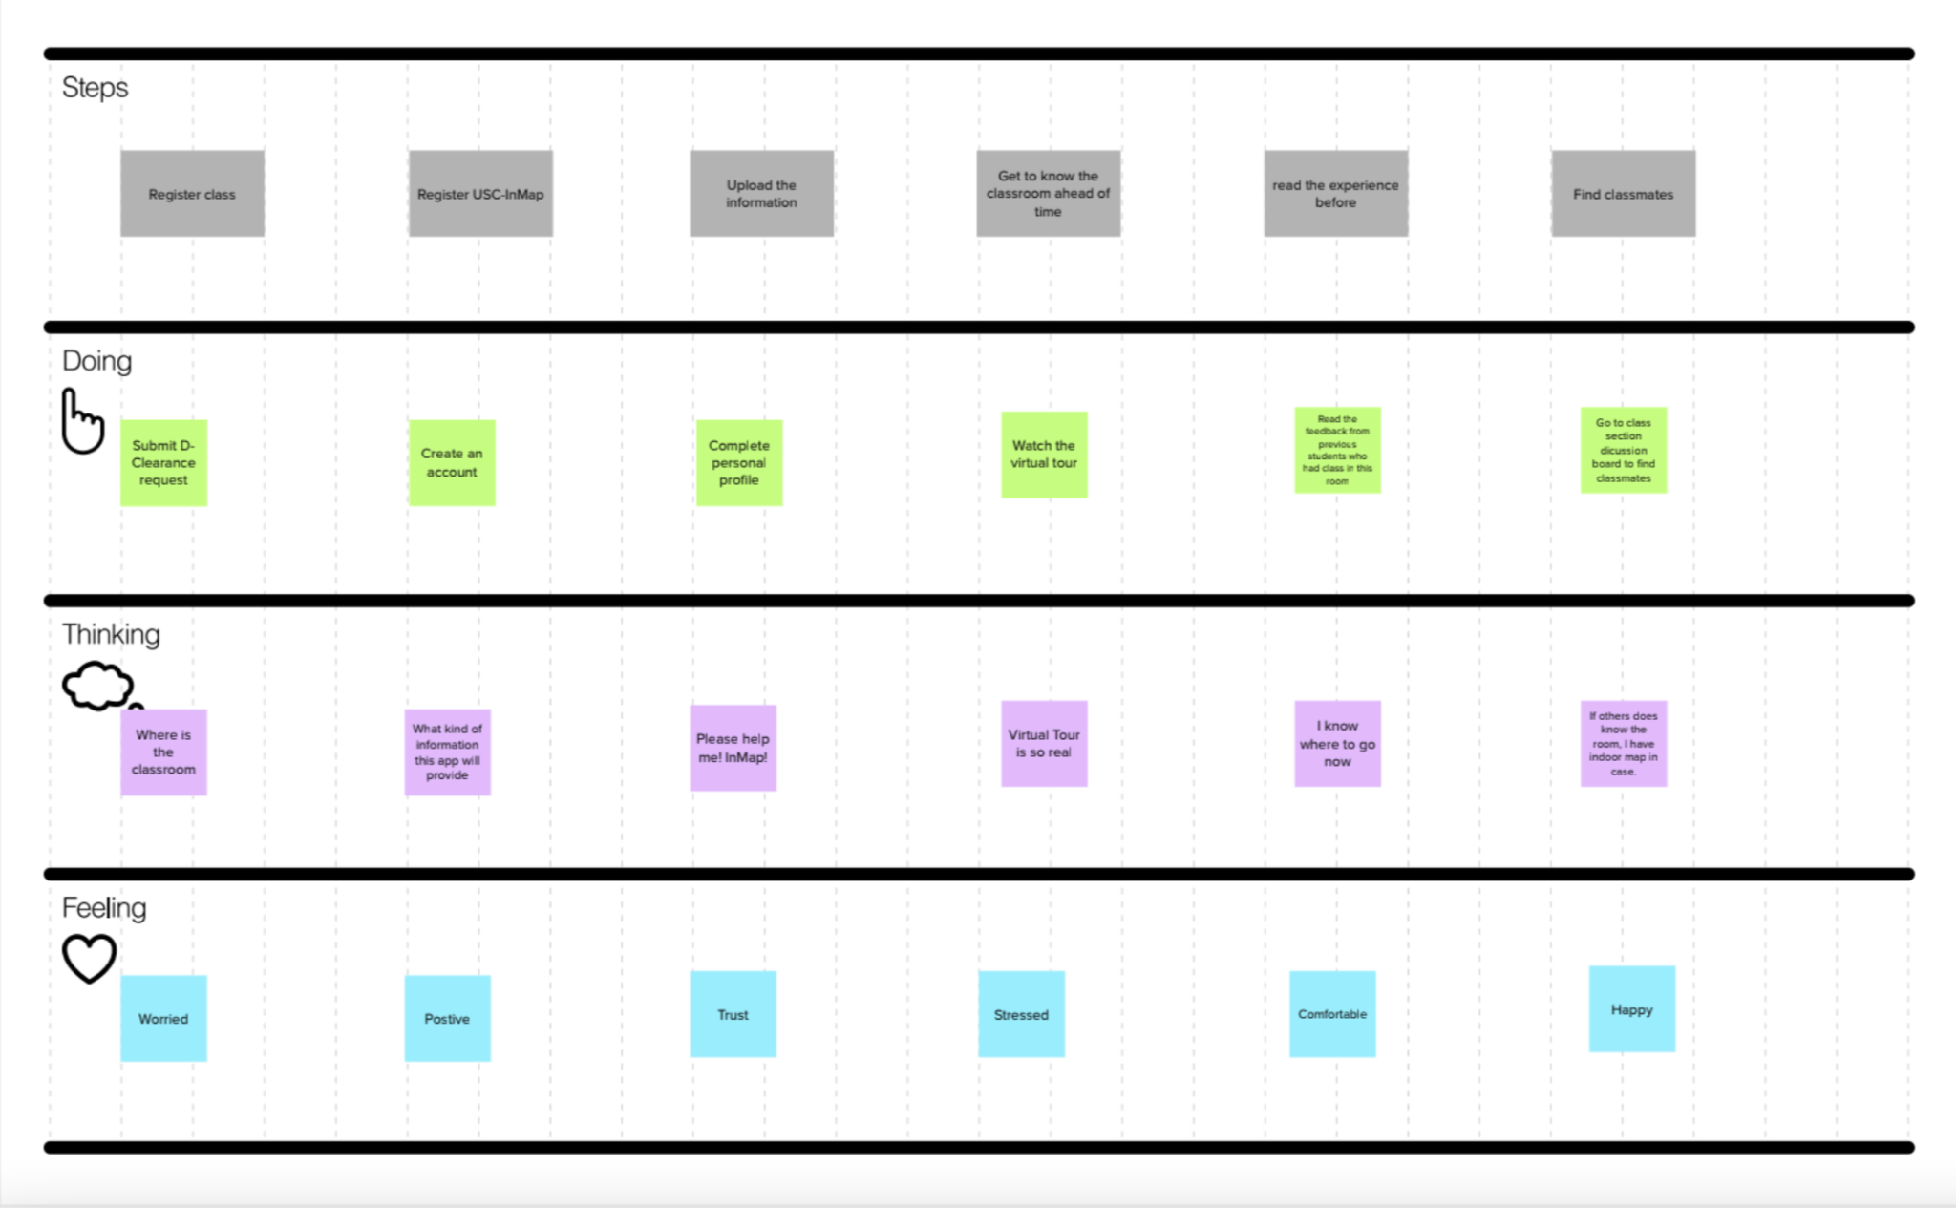

### Scenario 2

It is the first day of class. James Green got lost in the building and there is 5 minutes left before the class starts. He wants to find the classroom and attend class on time.

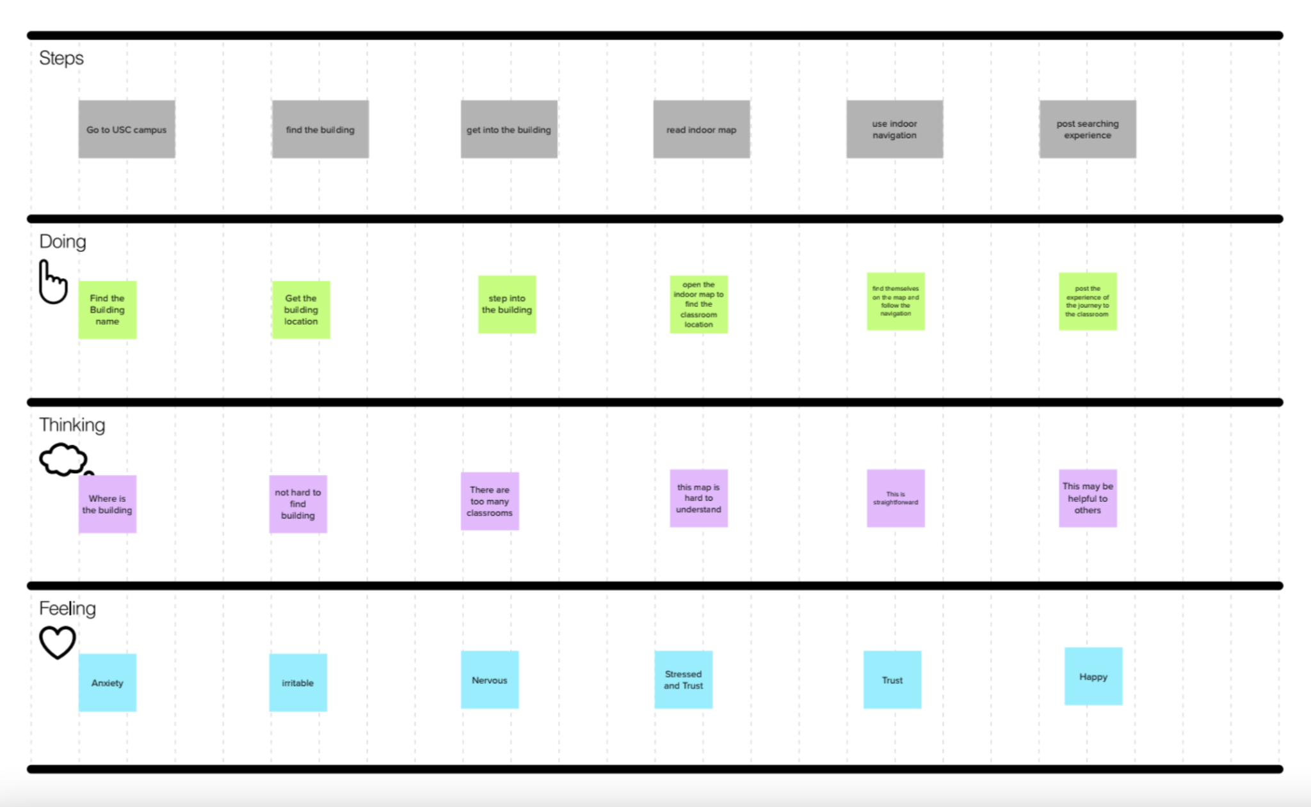

## Storyboards

Once the Scenario Map has been completed, it is then possible to enhance it with visuals and captions, thus creating a Storyboard. These storyboards show how users may use USC Inmap. It displays users’ entire process from thinking about what they want to do, and then how USC Inmap helps them to find the classroom that they want.

### Storyboard 1

Stephen White is afraid of not being able to find the classroom and he signed up on our platform after he registered for class.Now, he needs to do some preparation before the first day of class.

#### Key Features

* **Virtual Tour**: This feature simulates an actual area and is typically made up of a series of films or still photos. Customers can use it to explore the campus virtually and get the full campus building exploration and discovery experience.
* **Discussion**: This can be used by students to have discussions or get to know each other. As a result, students can contact classmates before the class begins. Students can use this tool to get to know more people in the class in addition to locating the classroom. Students can participate in class discussions after creating accounts and adding their course.

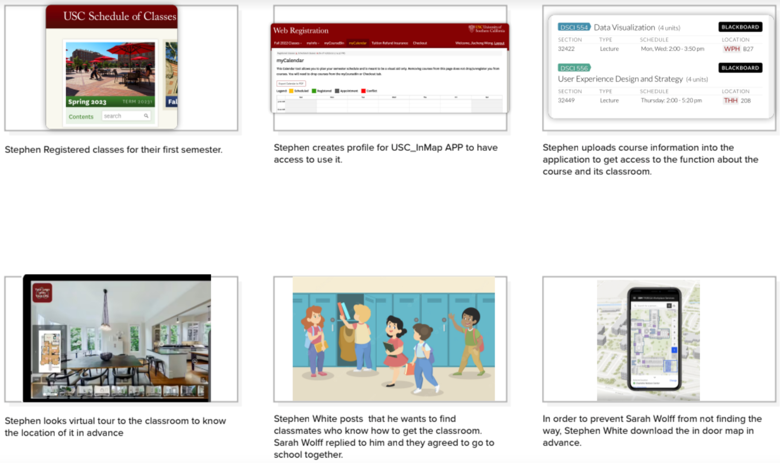

### Storyboard 2

It is the first day of class. James Green got lost in the building and there is 5 minutes left before the class starts. He wants to find the classroom and attend class on time.

#### Key Features

* **Navigation**: People can use this feature to find their way both inside and outside of a building.Users can use the in-door navigation feature to see the route to the classroom in real time. This feature allows users to find their way to the desired classroom and avoid getting lost inside the building. Customers who struggle to read the indoor map and figure out the direction might also benefit from this feature. This can be used by anyone looking for a classroom in a particular building.
* **Indoor Map**: This can be used to scale drawings that depict the relationships between rooms, spaces, and structural elements as seen from above. This feature, when used in conjunction with indoor navigation, could help students locate a particular classroom quickly, assisting those who become disoriented inside buildings, particularly at the start of semesters.

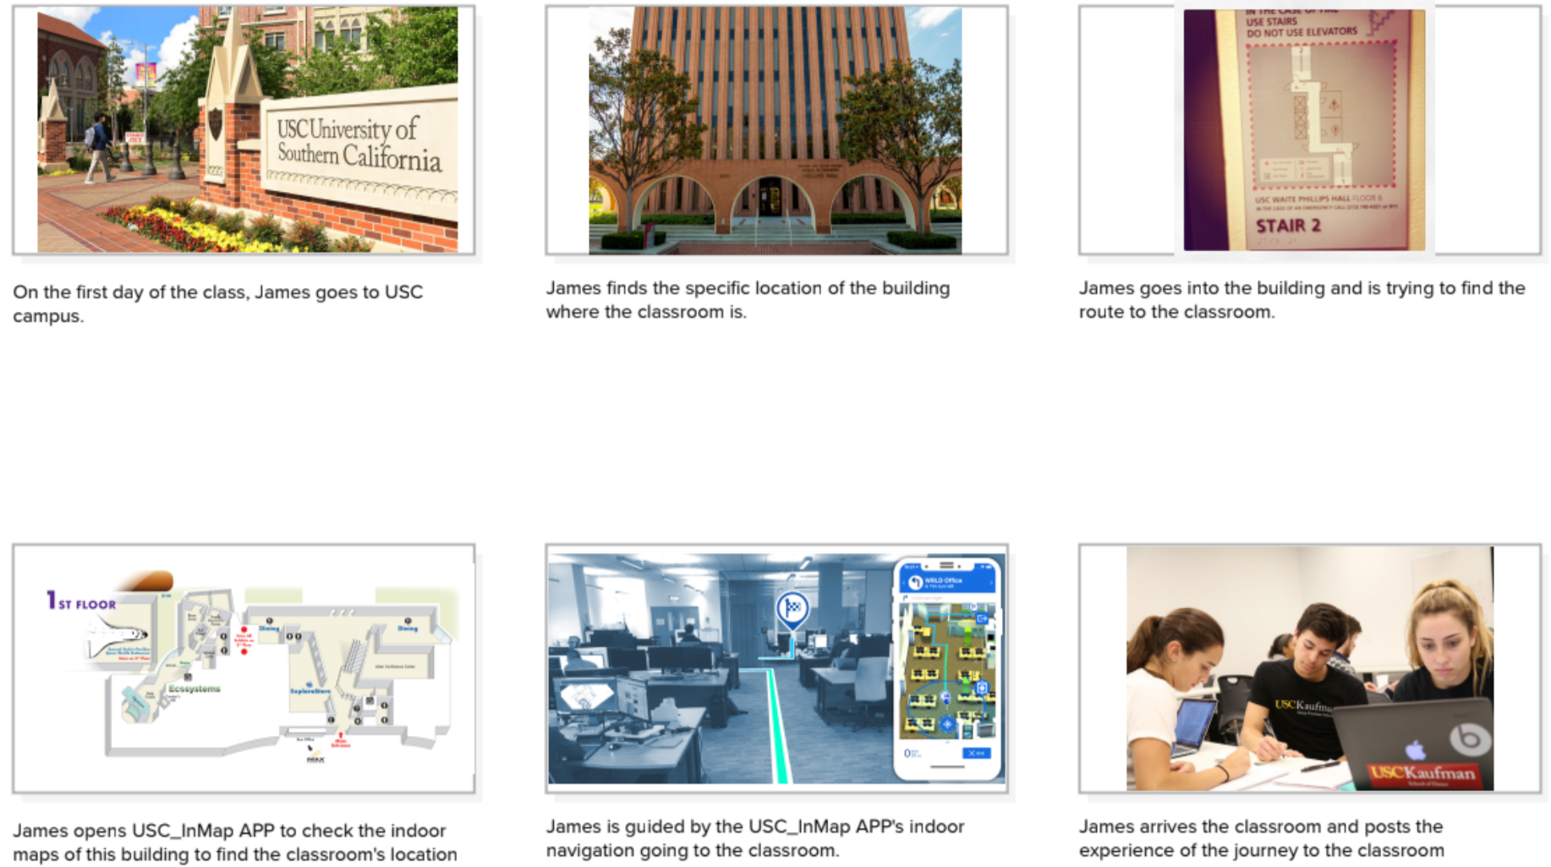

# 

# Prototype Development

[USC_INMAP – Figma](https://www.figma.com/community/file/1166554730480112281)

## Prototype

1.**Sign In:** Customers can sign in with their USC account, and also sign up.

2. **Home:** Show personal information and provide functions like Profile, Change password, Notification preferences and Log out.

3. **Profile:** Show customers’ personal information and the information about the courses they registered.

4. **Search:** Customers can search a building or a room on USC campus.

5. **Building Detail:** Show the floor plan of each floor of the target building or the specific location of the classroom in the building, and also provide a virtual tour for the building.

6. **Indoor Map:** Customers can zoom in on the map by clicking on it to get more detailed map information.

7. **Navigation:** Provide indoor and outdoor navigation, giving customers more specific time forecasts.

8. **Virtual Tour:** Customers can use it to explore the campus virtually and get the full campus building exploration and discovery experience.

9. **Discussion:** Provide a section for students to have discussions, get to know each other and share the experience about the classroom finding process.







## User Research

| **Hypothesis # 1 (value proposition): Customers need to locate classrooms at least twice a semester.** | Do you have a need for finding a classroom on the USC campus? When will you use it? How frequently you might use this app? | 100% positive feedback |
| --- | --- | --- |
| **Hypothesis # 2 (Indoor map):**  **Customers use our indoor map to visualize an indoor venue.** | Do you think our indoor map can help you to find the classroom? Do you think indoor maps are hard to understand? | 100% positive feedback |
| **Hypothesis # 3 (Indoor Navigation): Student needs a real time navigation to the specific classroom** | Do you think indoor navigation functions will help you find the classroom? | 87.5% positive feedback |
| **Hypothesis # 4 (Virtual tour): virtual tour of indoor and outdoor of the campus.** | Do you sometimes find it difficult to know where you are on the map? | 100% positive feedback |
| **Hypothesis # 5 (Discussion): Students would want a place to ask for the exact location of the classroom and know new classmates** | Do you think discussion functions can help you find the location of the classroom and know new classmates? | 100% positive feedback |

Every hypothesis is validated, which means that we made good assumptions about the user experience of our product. Clearly, the features we made are useful to users, which can help them get what they want.

For Indoor maps, users agreed that it is very useful and some of them are hard to understand. So, we provide more specific information about indoor maps and more straightforward methods to help users to find the classrooms.

For Indoor Navigation, most of the users think it is useful. Based on the result, we provide an extra outdoor navigation and estimating time.

For Virtual Tour, sometimes users can get lost in the building, so they agreed that this function is very useful to help them find the classroom in the building in advance.

For discussion, users thought this is a good place to discuss with their classmates about the classroom location, finding study partners and also carpooling, all the topics related to our classes and classrooms.

## Design Iterations



**Homepage:**

1. It displays more information and provides more functionality.

2. Users can click the profile to see their class information.

3. Users can click the navigation button in their class table and jump to navigation page.





**Indoor Map:**

1. We added more detailed indoor maps and refined the search function. There are currently two search results. The precise classroom or building can be searched for by users.

2. The user can switch levels to view the door map of various floors if they are searching for a specific building.

3. Users can zoom in on the door map to see it more clearly by clicking on the indoor map.



**Navigation:**

1. We added different ways of transportation, walk, bicycle or drive.

2. It displays how long it takes to navigate indoors and outdoors, respectively.



**Virtual Tour:**

1. We added VR indoor navigation.

2. It displays a more detailed guided route.





**Discussion:**1. A brief overview of the discussion function is shown to users when they utilize it for the first time. Close button will take users to the next page.

2. We add more information to the discussion page. Firstly, people might use keywords to search the post. Secondly, we add the option for users to select the category of the post they want to read. Finally, the name and profile photo are added.

3. The content of a post is displayed when a user clicks on it. People can sort and reply to the post.

4. We include the option for users to publish new content.

# Business Model Canvas & Lean Canvas

## Business Model Canvas

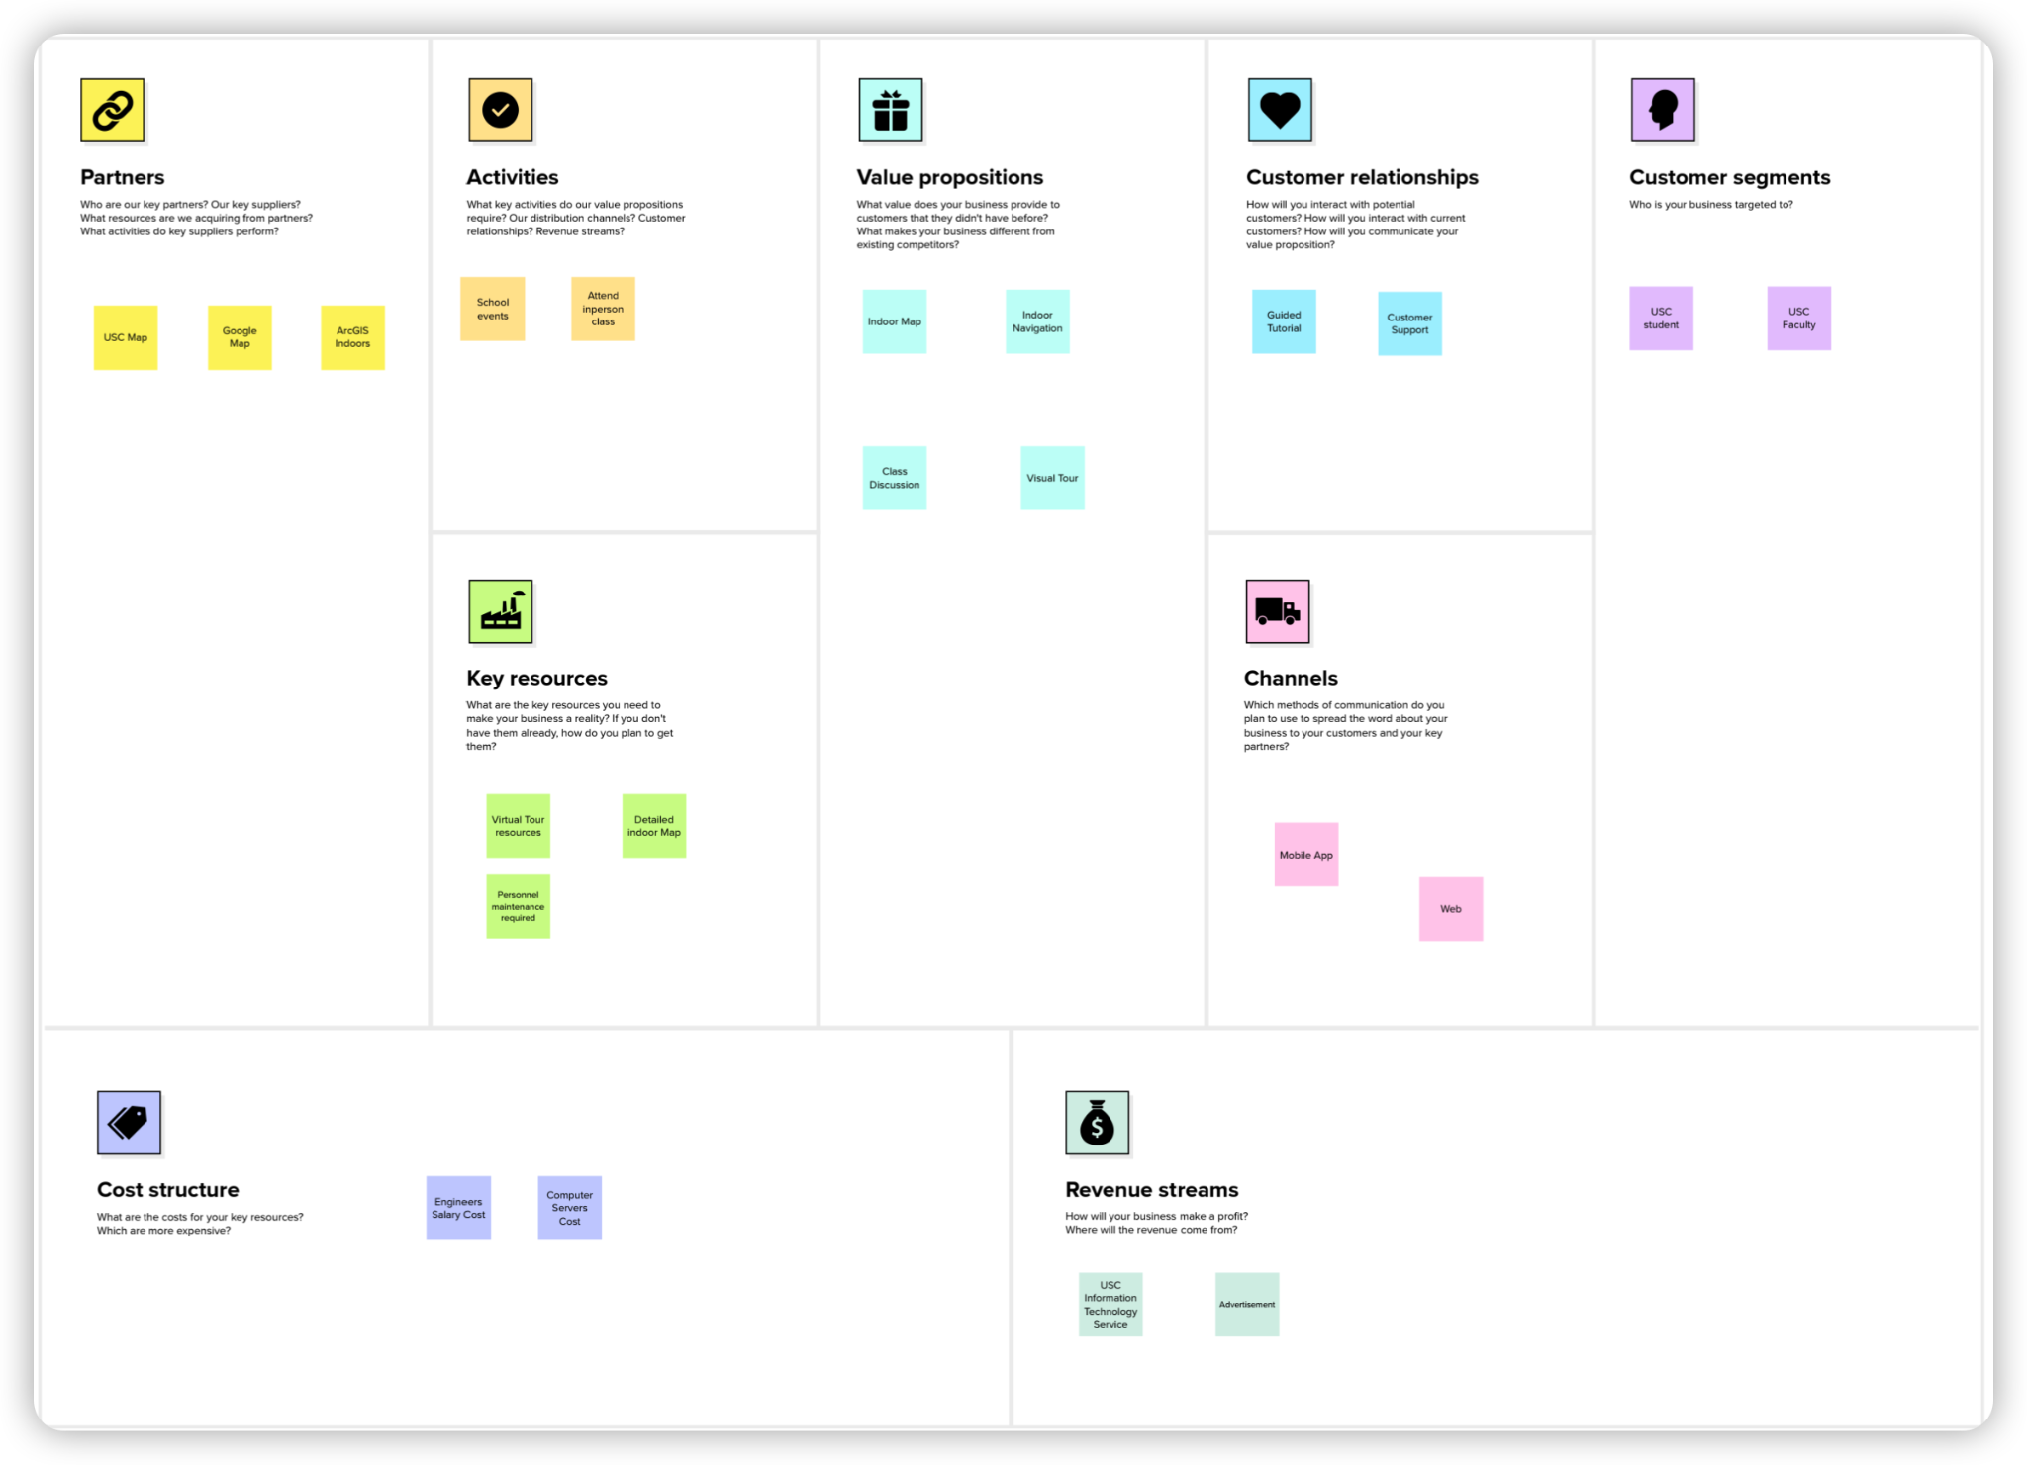

This canvas depicts the business model of our project Inmap. It describes how USC Inmap generates usage value, and secures financial sponsorship. It is more focused on providing effective assistance to students in order to obtain financial support from the university.

## Lean Canvas

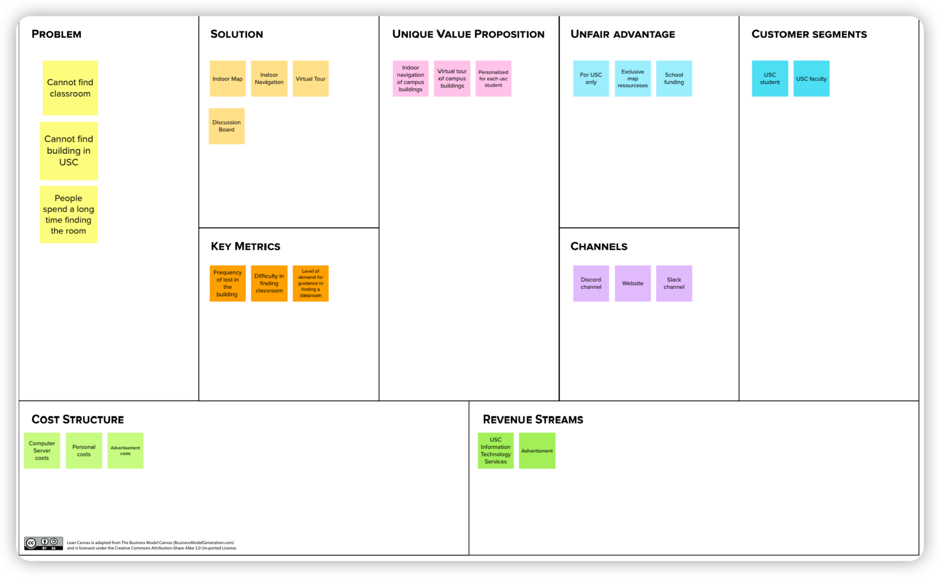

This Lean Canvas is another visualization of our business model. This canvas highlights some of the possible problems with the current business model, allowing for more targeted improvements. We can make real-time updates as issues change from time to time.

# Conclusion

## Reflection

A clear path to help users achieve their goals when interacting with the product is part of good UX design, which involves thinking like a user. We have a lot of preliminary work to perform before we can submit a new application. We must identify our target audience users and consider their demands from their perspective. Additionally, we must consider how our product will generate revenue and which features would require maintenance expenditures. When designing the prototype, we discovered that not all features could be used and also that it was crucial to think about how to integrate them. Users told us they wanted us to add additional features after we designed the prototype for the first time. As a result, we also had to make decisions based on user feedback.

## Recommendations

So far, comprehensive and effective outdoor navigation is mature enough to meet the needs of most people, but for indoor navigation, especially for specific locations, such as the USC campus, there is no method that can provide effective indoor navigation, so our product is especially important for people with this need. Therefore, creating a comprehensive and specific indoor mapping system for USC buildings is critical. In addition, given that enough virtual tour technology is already available, we can meet the need for such functionality by inserting relevant plug-ins into the product. Besides, our product can also enhance the user experience by providing more user information management, system settings, etc. All in all, UX design is a process of continuous improvement, and we still have a long way to go before our products are really adopted.

## Next Steps

The current questionnaire and feasibility analysis only includes the opinions of a few students, and we need to take more opinions from potential users in the next step. We also need to make a more detailed estimate of the possibility and cost of implementing the technology. We will cooperate with the relevant departments of the university to obtain clearer indoor maps, and actively seek financial support from the university. We will also add stop in the process of navigation, so that users can buy coffee on the way to class, etc. We believe that our product USC InMap has its market and can solve the pain points of some students, and we will improve our product according to the needs of users.